[Be sure to read the Jan 30 article. It’s more important!]

Wednesday, January 28. 2009
Posted by Karl Denninger at 06:58
(Page 1 of 347, totaling 693 entries) » next page

Bad (United States) Bank (FDIC/Treasury)
Oh boy.
Markets, guys and dolls, markets.
Obama's administration is supposedly going to announce in the next few days a "good bank / bad bank" scheme to supposedly "take the bad assets" off bank balance sheets.
They are apparently going to do two things that will lead to severe longer-term problems for our economy and Treasury:
- They intend to use a model approach to valuation (as opposed to the market) AND
- They intend to assume in that model that the government can borrow very cheaply over a long period of time in that model.
Does anyone remember how well it worked out when we "assumed" that home prices would never go down?
Well, this is just about that stupid, but it is apparently what they intend to do, this time intentionally (well, ok, last time was intentional too) overpricing "assets".
When (not if) borrowing costs move upward for the government this will produce an unfundable federal debt. And no, The Fed cannot "cap" interest rates for any length of time without immolating itself.
Therefore, down the road this is going to be insanely destructive, and probably not far down the road either - I suspect the market will figure this out in a few months and then the wheels will really come off.
This move has caused me to gain considerable confidence that my SPX 500 target (that is, S&P 500 trading at 500) will be reached sooner rather than later, and perhaps a lot sooner.
There are some hints out in the press that the one way they could do this in a reasonable fashion might be on the table - that is, have the FDIC run the "bad bank." While this has its problems the good news is that it would place control with the people who can come in and SEIZE said banks down the road if in fact the "good side" isn't really so good, leading to an RTC-style solution that actually will clear the market.
If and when that RTC-style solution is enacted (seizing the banks) you can bet it also will crash the stock market, because such a move instantly zeros the equity (stock). While this sounds horrible it actually isn't - it's good, because that will mark the end of the credit problem - the bad debt will be flushed along with the underwater banks, the banking system will be preserved and remain functional, the losses will be known and the economy will trough and be able to recover.
Oh, it will also flush the worthless executives - both on the boards and in the corner offices.
Because a true RTC-style flushing of the "vendors" of the trash will produce an equity market implosion you can also bet that "they" will avoid doing it for as long as is humanly possible. Only when the FDIC (if they wind up doing this) run out of money and have to go to Congress or similar will the proverbial brown stuff hit the airmoving device.
In the meantime you can bet this move will produce a major "rip your face off" rally in the financials and thus in the broader market here and now. That's a lock and I'll eat my WSJ if it doesn't happen. [But see below what he’s saying only ONE DAY LATER!]
So this leads one to question - where are we headed in the markets?
Here's my answer in the short term (next week to next month or two):
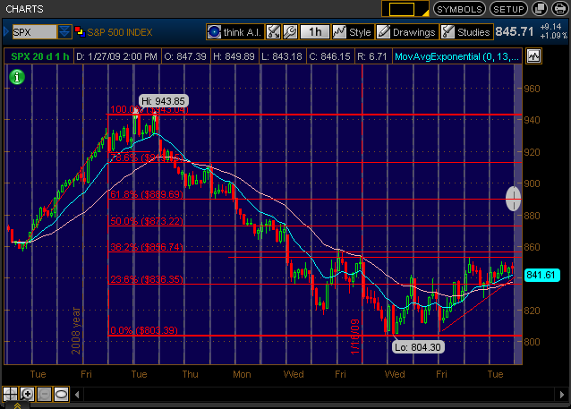
In Technical Analysis terms in the very short term (next few days) we are almost certain to go after that oval on the chart, which is the 61.8% "retrace", or movement backwards, from the latest plunge. This targets 890ish.
We might get there as soon as today, especially if The Fed says something that the market likes (and it probably will.)
In the intermediate (next couple of months) term I suspect we're headed for one of the three ovals in this chart:
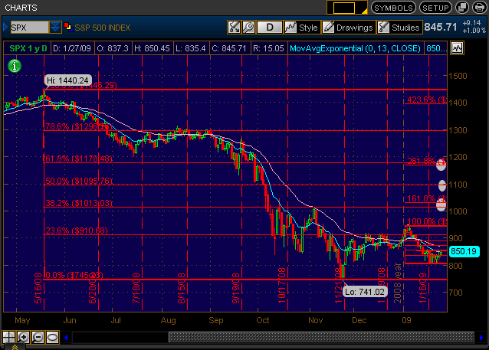
That's a long way up.
Don't mistake this for a new bull market. It's not, although I'm expecting plenty of people to call one really, really soon, likely as soon as we break out of this trading range and clear 900. Those who have been foolish enough to be aggressively short looking for "new lows tomorrow" (and there have been a lot of them) are about to get it in both holes, and when they capitulate prices will be driven even higher.
For a while.
My view? This is a great trader's market. There's plenty of money to make off this move, and when people figure out that this won't work in that all it has done is trade one bad set of models for another and the only real solution is to seize some of these banks the collapse will be equally impressive. In the meantime I enjoy the opportunity to ride this sucker up and get massively short at a better price.
If you're not someone who plays short, watch those levels in the second chart, and when and if they're hit consider raising lots of cash.
Consider the risk:reward profile - if we get just to the first marker, you will have seen a 30% rally from the bottom and about 16-17% from last night's close.
What upside are you missing if you hop out and there is a magical unicorn that appears and saves the world before you are certain that's the case and re-join the party? Another 5, 10%?
On the other hand if we ping there [i.e., “people figure out that this won't work”] and collapse by half you're fixing to lose half your portfolio - again. That's a 66% loss from the top, which is really going to hurt, especially when you only had to lose 1/3rd and just watched the market ramp - and you didn't sell into it.
If I figure out the triggering event for "realization" I'll try to post it - hopefully before the collapse really gets going.
If you're wondering how sure I am on this plan being the catastrophe that I'm predicting, let me put it this way:
Either there's some sort of "gotcha" in the leaked plans and Steve Liesman and CNBC are being used as a stooge in the government to set up a rally on a false premise, OR this is a catastrophe "as implemented" down the road.
Either way the outcome is the same; we're arguing only about time.

Friday, January 30. 2009
Posted by Karl Denninger at 06:52

On The Edge of The Abyss
[This second Denninger article lays out the new thinking (see points 1,2, and 3) and it seems he's just recently decided that this bad bank (aggregator bank) isn't going to fly and that the new administration is dissembling or naive.
- If the bad assets are valued too high, selling them to a bad bank is inflationary. Gov't can't allow this.
- If the bad assets are valued too low (marked to market, more or less) then the banks are bankrupt. One of them said a few days ago (JPM?) that it probably wouldn't use a bad bank.
- Nobody knows if there's a sweet spot in between or how to define it. - a research project!
- Fred Chase]

So you recently saw my short-term and intermediate-term targets and the rationale for them.
Today you're going to see my warning - to The Administration, to anyone who will listen, which, it appears, is nobody.
If nobody "in power" wants to hear it at least the people deserve to be warned so you know what can happen if poor decisions are made.
You're getting this on a "one night" delay; it was a major feature of my nightly video last evening on the forum..... but better late than never, and I decided, given the early-morning action in the futures, that this had to be put where everyone can see it.
Before I present this chart, I want to make clear that this is NOT a prediction. It is, however, a caution. It is a place we can go, but not one where we must go.
This, should Obama or others in Congress and The Administration try to play "too cute by half" and jack around the markets, the public, and the world, is what is going to happen:
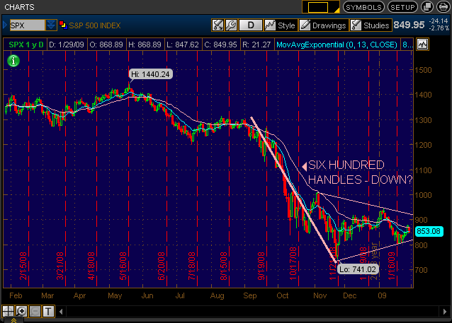
That structure is known as a "pennant" or "symmetrical triangle."
The rules of technical analysis for this pattern are:
- Pennants are continuation patterns - that is, whatever direction the market is moving when it comes in, it will move when it comes out.
- The minimum target for the move is given by the length of the pole to which the pennant is attached.
[Charts for a government-manipulated market, such as the spot gold market, violate even the most reliable technical analysis principles. The largest capitalization broad based indexes are relatively immune to manipulation. The S&P 500 is in between. It is substantially immune to manipulation except overnight. –FNC]
In this case the pennant prognosticates a move downward of six hundred S&P 500 points from the break, which occurs at approximately 810.
That gives us a target on the S&P 500 of 210.
No, that's not a misprint.
I said two hundred and ten, and I meant two hundred and ten.
This puts the DOW at TWO THOUSAND.
Mr. President, Congress, and the rest of the fools in Washington DC, including TurboTax Timmie: You only get one shot at this and you better stop writing checks with your mouth that you cannot cash. This goes DOUBLE for Ben Bernanke.
Bernanke wrote one such check the other day in which he threatened to "monetize" the long end of the bond curve in the Fed Announcement. In response while the stock market was down big, the bond market called his bluff by ramping long-end yields and the Treasury auction this afternoon saw tepid demand at best. The TNX, or 10 year yield, was up nearly sixteen basis points or six percent, an outrageously large move upward on a day when the market itself was down huge (it should have gone the other way!)
The above pattern can break "wrong way." It does so over about 920 on the S&P 500. That, in fact, was what (until today) I thought was the highest-probability scenario - we would blow this pattern up, rally for a while - then we would start the next significant move downward.
I no longer believe that to be the highest-probability scenario for the following reasons:
- Bernanke bluffed and the bond market called it. He cannot monetize several trillion in new issue plus the entirety of the 10 and 30 year bonds out there to stop a bond market sell-off. In addition, the market no longer believes him, as evidenced by today's price action. A serious bond-market sell-off will ramp the cost of all credit, including mortgages and commercial loans. If he tries to monetize the result will be current bondholders tendering into his buying, forcing him to essentially [try to] "consume" the entire float. That stunt will cause the dollar to implode and we wind up exactly like Iceland. Overnight. Ben knows this; ergo, he is screaming like a petulant child while the market laughs at him just like the market forced Paulson to do what he said he wouldn't with Fannie and Freddie. Bernanke had better shut the hell up before he precipitates a bond market dislocation; traders can and will try to force him to make good on the threat.
- This caution goes double for Congress which seems to think it can blow money like crazy. Never mind Schumer talking about a $4 trillion tab for the "bad bank." We don't have $4 trillion and we can't raise it. That's simply off the table due to inability and thinly-veiled threats to attempt such a foolish action risk causing the very market crash that everyone says they don't want.
- Yesterday Steve Liesman from CNBC "reported" that the Administration had a "bad bank" plan that was momentarily going to be rolled out. Tonight we learn that just as with the original "Super-SIV" from 2007 (which was essentially the same thing), the un-resolvable problem is that the banks will not sell for the mark-to-market price (or anything near it). The unspoken reason is if they were to take the market price they'd be rendered instantaneously bankrupt. (This, by the way, is an admission that they are intentionally mis-marking these "assets" on their book now, or they'd have already been seized!) The government will not buy at "par" or anything near it because to do so will cause the taxpayer to suffer a trillion dollar loss; Goldman (and Schumer) both said this is a potential $4 trillion problem. Ergo, its a Mexican Standoff and there is no solution. This means that nationalization is still on the table. It also means that we're back to the days of AMBAC and MBIA - whenever the market was selling off hard on their "rumored" bankruptcy, Charlie Gasparino was trotted out by CNBC to claim that some sort of deal was imminent - and the market would instantly rally. These rumors all were false, by the way, and nobody took responsibility for that, nor will they this time.
- The "dirty secret" behind a lot of these "assets" is that they are literal zeros. A lot of the debt issued in the last few years was in fact fully synthetic - that is, it was not backed by an actual mortgage or other actual debt instrument - it was created out of swaps and other derivatives that "acted like" the real thing. The problem with this sort of model is that it relies on the ability of the counterparty who wrote the swap to pay - if they can't pay then what you have is a worthless piece of paper since you can't even foreclose on the underlying property and seize the collateral! With no meaningful margin supervision a lot of these so-called "counterparties" in fact can't pay. This means these "synthetic" instruments are in fact worth nothing.
- The pattern of our government since August of 2007 is to "dare" the market by making outlandish and unsupportable claims (such as Paulson's famous "Bazooka" threat) and effectively stare it down. The market calls all such bluffs with an "all-in" raise. It always has, and it always will. This is simply a function of how markets work; that we have people in positions of regulatory oversight over the Capital Markets that don't understand this fact given the hundreds of years of history on the matter is a mark of incredible arrogance. I had hoped that Obama would reverse this insane course of action and stop "bluffing"; the last two days have made clear that no such "change" came to power in Washington on January 20th.
We desperately need a real solution to this banking issue. In my opinion there simply is no "market friendly" answer. There are only solutions that respect the market, and then there are those that attempt to transfer the bad debt - of which there is a lot, to the taxpayer.
The latter cannot be done. Schumer (and Goldman) have it about right in terms of the capital required to pull that off, and the impossibility of funding such an exercise.
Therefore, the only rational answer to this mess is to:
- Defang the CDS monster. This must be done now. CDS provide a limited-risk and near-unlimited reward for shorting a firm's credit; this is exactly backwards from the equity markets where shorting is limited-reward but unlimited risk. Short-selling is essential to a balanced market but allowing CDS to be abused to invert the long/short risk profile is outrageous and must be stopped. The proper approach to doing this is to:
  - Force capital adequacy to be proved for all outstanding contracts. If you can't prove the ability to cover the contract, it is declared void.
  - Bar the writing of new CDS on any TARP recipient. The government has said it will not allow these firms to fail. The bets have been made; existing ones that can be covered by the writer are ok, but no new positions can be opened until the government's interest is extinguished in that name.
  - Require that all new CDS be written against a public exchange and direct the ISDA to produce, immediately and nightly until that has taken place, bid/ask/OI on an accessible public interface.
  - Consider barring all CDS that are written "naked" - that is, not against a deliverable bond. There are already-existing means to short a firm you believe is in trouble in the equity, options and futures markets. The inversion of the risk:reward profile in the CDS market is a big part of the problem and we must consider putting a stop to it.
  - Do this all right here, right now. Give market participants a very short term (two weeks, maybe four) to get their act together or face having their contracts rendered noncollectable.
- Send in the bank auditors and examiners, suspending all bank share trading for two weeks. Mark everything to the market. Anyone who is insolvent under Tier Capital rules gets crammed down ala-The Genesis Plan. All firms that are crammed down have their boards and management removed; the new equity holders (former bondholders) get to elect new management to run the firms they own without prejudice (if they want the old management back, they're welcome to have 'em, but there is no ability to manipulate the vote by entrenched management!) All firms then re-open for trading at the same time - but existing shareholders (including preferreds) of the "crammed down" are wiped out.
- For those firms that cannot survive even when crammed down they are instead seized by the FDIC and RTC'd. This works exactly as it did in the RTC days; the FDIC gets the assets in exchange for guaranteeing deposits, and disposes of them in its self-funded "bad bank." That is a "bad bank" model that can and will work and has no "asset valuation" issues.
- Be prepared to use the second half of the TARP funds to either internally capitalize new banks which will then be spun off to the public or add capitalization to existing good banks. The cramdown and receivership of the bad banks will undoubtedly lead to lots of guaranteed deposits and good assets needing a home. There are hundreds of perfectly solid existing banks that should be permitted to grow their asset and deposit base by feasting on the carrion of the deposed.
- Start investigating the fraud, and be vigorous about it. The public is not going to sit for their 401ks being destroyed as they have already (and will be as this plays out) without blood. There are lots of bad actors out there, starting with the officers and boards of failed institutions. These were not just "bad bets" that caused our banking system and economic problems - I'm willing to wager that it can be proven that they were knowingly-unsound bets and the mismarking of "asset values" was not accidental either. Down this road should lie plenty of securities fraud charges and maybe more than a bit of Racketeering. Go for disgorgement of the ill-gotten gains to at least provide the people with something to refill the treasury and assuage the anger, along with prison sentences.
There is no "market-friendly" solution to this mess folks. There are, however, disastrous decisions that can be taken, and continuing to hide losses - and the truth - will lead directly to that disaster.
We must deal with the bad debt by forcing it into the open. Transferring it from one pocket to another fixes nothing and if we're not careful we will wind up precipitating a bond market collapse coincident with the stock market melting down to a degree that is several times worse than what we saw in September and October.
Unless President Obama wants to be known as our second Herbert Hoover, he must not allow the game-playing to continue any longer.
Neither you or I want to see the S&P 500 collapse down into the 200s with 75% of the listed firms in this country going under. Nor do we want to see 20 or even 30% unemployment. I'm sure you're not interested in seeing not a 30 or 40% loss in your 401k as you had last year, but an 80% loss. And I'm very, very certain that having the government - both state and federal - unable to raise operating funds and being forced to cut off social services and entitlements is not on your "desirable" outcome list. Yet all of this can and will happen if the bond market dislocates and starts a cascade. The price action in the market over the last couple of weeks is a strong warning that "borrow and spend" will not work and the market is getting rather upset with papering over ever-expanding losses.
It would be nice if President Obama had several weeks or even months to coordinate a strategy. Unfortunately the market doesn't work this way, and it appears that he is being forced to either crap or get off the pot essentially now, lest the market decide for him.

